Ultimate Redneck Railroad Defense

Curt Henrichs. February 4, 2017.

# Introduction

Jumping from the floating saloon you make your way through native American forces attacking a train. As the scenic backdrop fades into the distance you must save the train with your trusty shotgun and rifle. Ultimate Redneck Railroad Defense (URRD) is a 2.5D side scrolling voxel shoot-em-up starring the saloon’s finest redneck.

## Character Bios

### Redneck

(Playable character) Trained as a cowboy, he rides in the floating saloon towards the native American raid on a train that he has pledged to protect. He is average height and weight. He prefers to wear a brown leather trench coat and his cowboy hat. Weapons of choice are a rifle and a shotgun. He can use his shotgun for both destruction and to aid in jumping/hovering. Source of food is the chili pepper used to restore his spiciness to continue the fight.

### Native American Brave

(Enemy) Generic native American with a vengeance against those that take his home land. He attacks trains with either a spear or bow. He is not very smart and will wander around on his section of the train waiting to face those who challenge him. He chooses to wear traditional native American clothes into battle.

### Native American Chief

(Enemy) The chieftain of the raiding force has felt the transgressions against his people. He has chosen to attack this train as a statement of war against those who take his land. He battles the rednecks with arrows coming from his headdress when at range and a spear when close. He is much stronger than a brave. He wears traditional native American chieftain clothing.

## Plot

Player starts the game which leads to an animation of the floating saloon approaching the train. The ultimate redneck jumps out and lands on the back of the train. Player then controls the character as they fight to the front of the train. If the player dies, then game moves to death animation and returns to menu. When player clears the chieftain at end of the train they win and message is displayed stating that they win plus the score. After win animation, the game returns to the main menu.

# Gameplay

## Description

2D platform movement is focused on traversing the train by moving left and right along with jumping. Shooting involves tracing a target cursor on screen with the player’s arms and firing either the shotgun or the rifle depending on user input. The gun should provide kickback to move the player and if shot is aimed down then the player will get a boost up.

The player will attack enemy’s that track once the player gets close. Killing an enemy will be rewarded with points that accumulate to give final score. In addition, the points fill a meter for a special attack bonus.

Player heath is full at start of level and is decreased when an enemy lands a successful attack. Killing an enemy may cause a pepper to drop which when walked over will give health to the player. Losing all heath is death which causes the game to end in a loss.

## Artistic Style Outline

### Visual

Voxel-like models. Terrain is wild west desert / canyon. Train is a steam locomotive. Native Americans are dressed in traditional garb. The visuals may be slightly exaggerated similar to a cartoon.

### Audio

Old western style music. Slow during the meu but picks up a beat when in a level. Has to sound cool for someone who would enjoy country music and westerns.

Sound effects will be exaggerated/comic in nature think Mario-esc sound effect feel. Possible heart beat when health low.

## Game Flow

The game flow diagram is presented below.

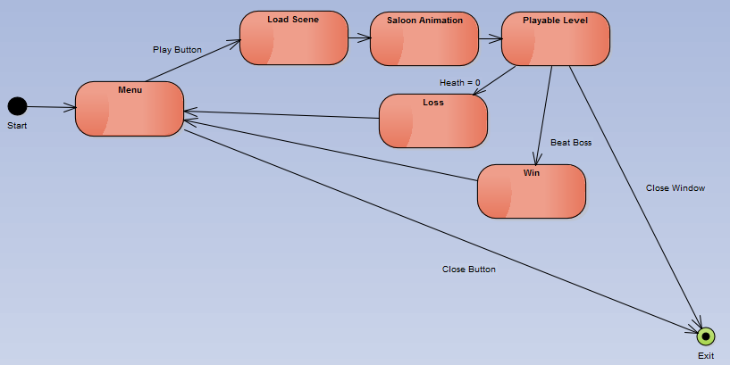

Figure 1: Game flow graph shows the main components of the game.

# Design

## Component Breakdown

## Asset Breakdown

### Menu

* Play Button, Close Button Graphics
* Title Graphic
* Menu Manager Script

### Blimp

* Blimp Model
* Blimp Animation Script
* Saloon Model
* Sign Model

### Terrain

* Voxelized seamless terrain chunks
* Intra-terrain generator script
* Inter-terrain generator script
* Vegetation models (various grass and shrubbery)
* Rock models (various sizes and configuration)
* Tile-able ground textures

### Railroad Track

* Track model
* Bridge model

### Train Engine

* Voxel Model
* Wheel animation
* Steam Particle Effects
* Dust Particle Effects

### Train Car

* Flat Car
* Passenger Car
* Storage Car
* Caboose

### Storage Items

* Crate
* Barrel

### Player

* Player Model
* Player Animation
* Weapons and attack script
* Health script
* Movement script

### Native Americans

* Brave Model
* Chief Model
* Spear, bow for brave
* Attack script
* Movement Script
* Health script
* Animation

## Additional Ideas

* Backdrop interior saloon scene for start menu
* Different terrains, regions for the level

# Timeline

|  |  |
| --- | --- |
| Feb. 17 | Nothing |
| Feb. 18 | Nothing |
| Feb. 19 | Nothing |
| Feb. 20 | Nothing |
| Feb. 21 | Nothing |
| Feb. 22 | Nothing |
| Feb. 23 | * Player * Blimp |
| Feb. 24 | * Menu |
| Feb. 25 | * Enemy Prototype Script |
| Feb. 26 | * Train Prototype Script * Crate and Barrel Model |
| Feb. 27 | * Train/Car Models |
| Feb. 28 | * Train/Car Models |
| Mar. 1 | * Train/Car Models |